Docking Forms

Introduction
The forms in the program can be left to float above the main window or can be docked to the top, bottom, left or right margins. This versatility give the user the power to build screens that are easy to use and tailored to the preferences of the individual user. Because of this versatility and wide range of options, managing the forms may at first be a little daunting; however with a little practice this flexibility can be employed to build the screen or screens that best suit the user’s mode of working.

DockPanel
This amazing versality is provided by an imported program module called DockPanel. It handles all the docking and management of the forms thus allowing the programmer to concentrate on the main purpose of the program. This superb module was written by Weifen Luo and made available at no charge via the Internet. He asks for no money, but does request an acknowledgment of his work.
This programmer is indebted to Mr Luo for his efforts.

Basic Docking
Basic docking involves locking a form against one of the four sides of the main window. A form can also be made to occupy the left-over space in the middle.
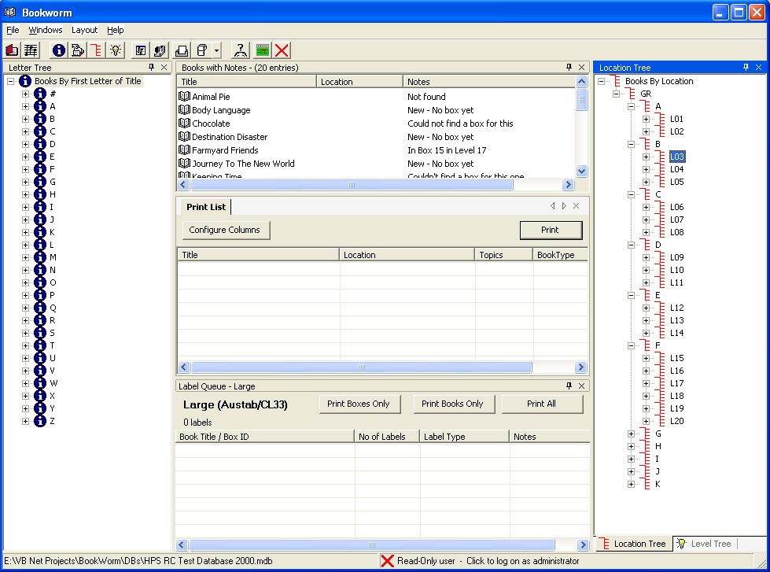 Six forms; one docked on the top, left and bottom sides of the main window, two on the right and one in the centre area.
Note the pane at right has two tabs, one for each of the forms in the pane.

Panes
A pane is an area of the screen, just like a window. The difference is that a pane can accommodate several forms by ‘stacking’ them on top of each other with only a tab showing to see what lies underneath. The user can click on the tab to bring a different form to the top.
Many panes we will see have only one form within them. They do, however, retain to ability to take more if the user wishes.

Picking up a form
Forms are docked by dragging them to different parts of the screen. To start we want to convert any form into a floating form. A floating form is simply one that isn’t docked to any side.
There are several ways to get a floating window:-
- The form is already floating
- Double-click on the blue or grey header bar of a docked form
- Double-click on the tab of a docked form
- Click, hold and drag on the header bar of a form
- Click, hold and drag on the tab of a form
Once a form is floating it can be dragged to be docked anywhere.
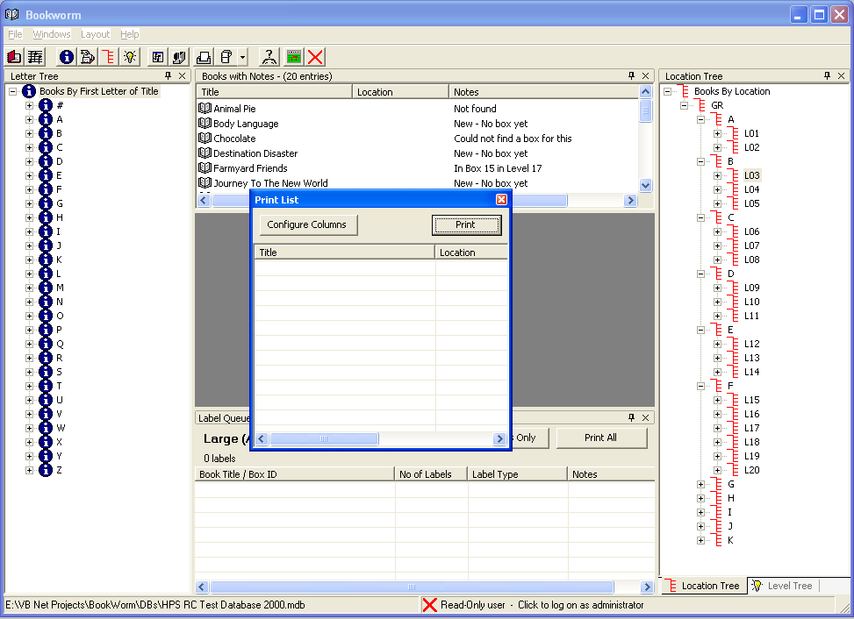 The Print List form has been made to float by dragging its tab. A double-click would also achieve the same effect.

Docking Suggestions
When a form is dragged to be docked, often there is more than one option available, so the program will show the result with a grey outline. These are called Docking Suggestions. The result will only occur if the user releases the mouse button at that point. By moving the mouse a little, often an alternate suggestion will appear.

Docking to a side
Tip:- On a blank main form with a grey background it is often impossible to see the docking suggestions. It is sometimes useful to start a unwanted form and fill the main screen with it before docking the required windows. When the layout is as required, close the unwanted form.
If a side does not yet have a pane docked to it, we can dock a pane there. If there is already a pane docked, then see the next section on sharing space.
Drag a floating form to the edge of the main form. The outline of the form will move with the mouse and change to a docking suggestion when positioned correctly. When docked the form will be within a pane.
The position of the mouse cursor is the crucial factor in successful docking – not the position of the form outline. Drag the form and position the mouse cursor just a few pixels in from the edge of the main form. In many cases, by moving backwards and forwards over the edge two docking suggestions will be made.

Closing a Form
Every form has an ‘X’ in its top right corner. This will shut the form down but leave other forms in its pane untouched.
If the form is the last or only one in its pane, the pane will disappear too.

Sharing Space
There are two ways to share an already-occupied space. These are called pane-splitting and pane-sharing. Unlike real life, our windows can fit inside a pane.

Pane-splitting
By dragging the floating window and positioning your mouse cursor near the edge of the pane to be split, you can get the two windows to split the space in half and see both, but with only half the space each.
This can be done vertically or horizontally by moving the cursor near to the left, right, top or bottom boundary of the window to be split.
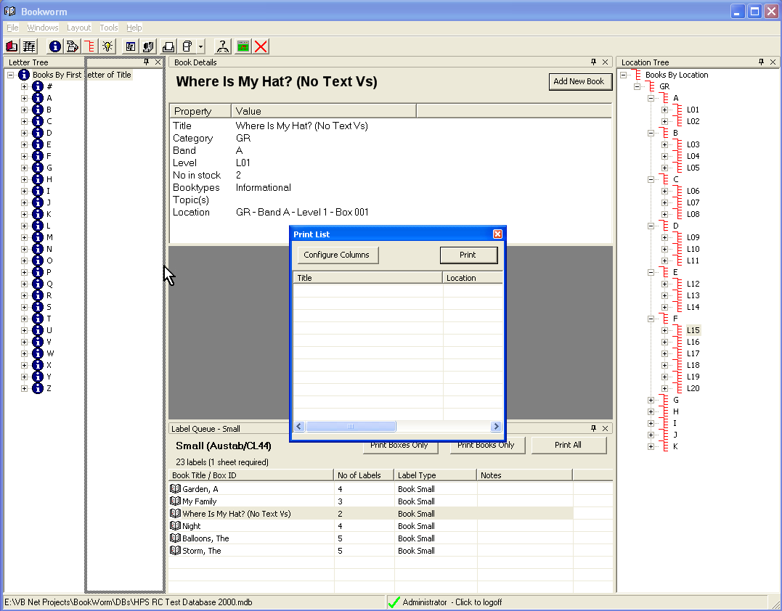Pane Splitting - Right
We dragged the floating window to share the pane containing the Letter Tree. The docking suggestion shows that form will divide the space vertically with the Print List on the right.

Pane-Splitting Examples
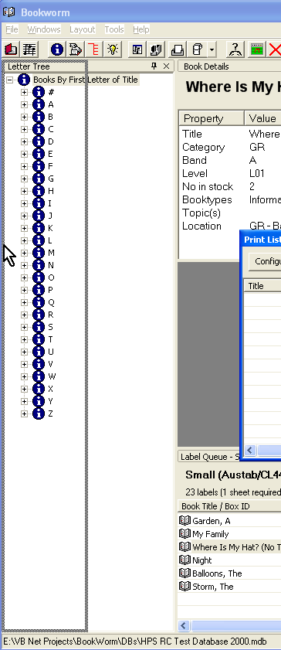 Pane Splitting - Left
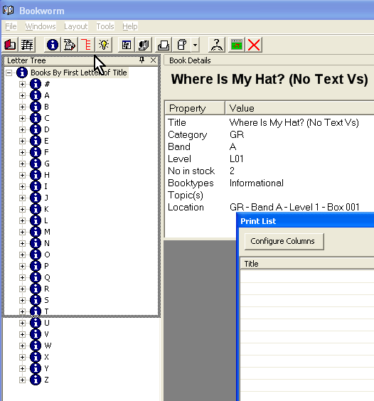 Pane Splitting – Top
This can easily turn into Pane-Sharing – the difference is just a tiny movement of the mouse. Move the mouse up slightly to get splitting if the suggestion is for pane-sharing.
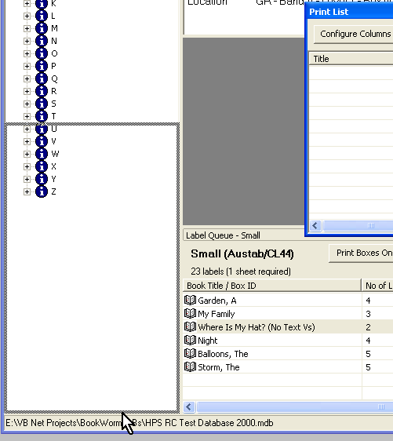 Pane-Splitting - Bottom

Important!
Each side of the split is a new Pane – which can be further split or shared….
If you have an enormous screen, you can split and share you way into a madhouse!

Pane Sharing
As an alternative to pane-splitting, you can get your windows to share a space – they will share a single pane. You choose the form to be seen from the tabs displayed at the edge of the pane. Drag the floating form so the mouse cursor is over the top of the form.
There are two slight variations on this, depending on the original form occupying the space. The form can be:-
- Docked on the side
- Filling the spare space in the middle (a ‘Document’ form)

Target is docked on the side
“How do I know?” – a side-docked pane has the push-pin icon on the right-hand end of the title bar to allow it to be slid out of the way.
In this case the docking suggestion merely outlines the existing form that currently occupies the pane.
It is fairly easy to get a pane-splitting suggestion when attempting this. Move the mouse down a little from the top to get pane-sharing.
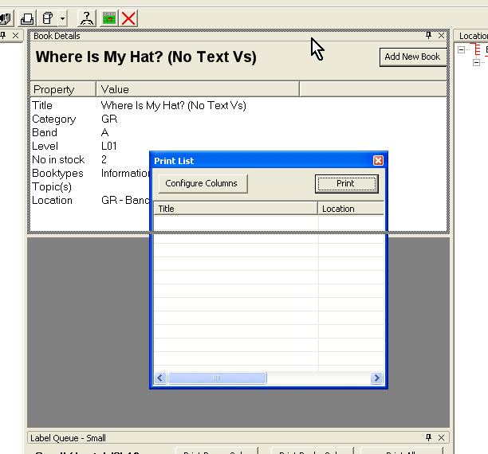

We have dragged the blue title bar of the Print List The docking suggestion tells us we will create tabbed windows sharing the space occupied by the Book Details form.

Note that side-docked panes retain the push-pin and have icons on their tabs.
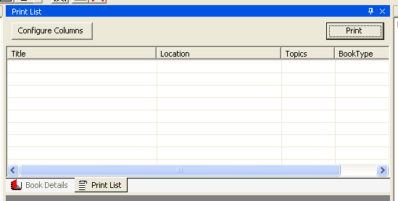 The result. Note the tabs with icons at the bottom.

Target is a ‘Document’ pane
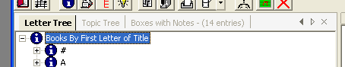
“How do I know?” The push-pin is missing; replaced by left & right arrow/triangles. The tabs have no icons.
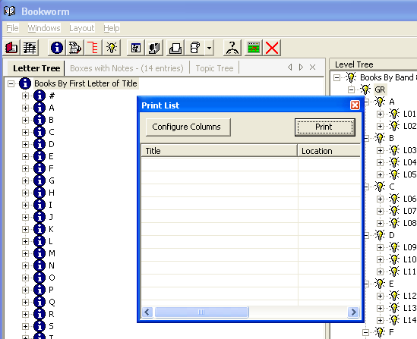

Starting layout. The Letter Tree & two others share a document pane
When we wish to share this pane, we need to drag, as always, but we position the mouse cursor over one of the tabs.
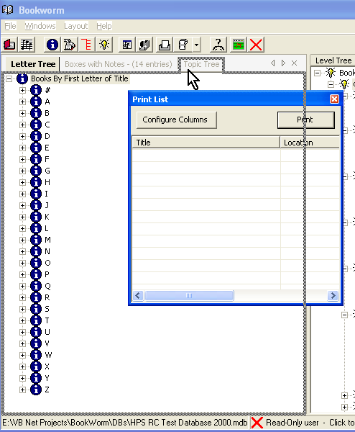
Release the mouse to drop the form in place.
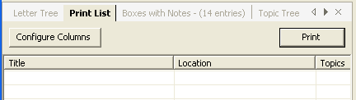
If, for some perverse reason, you do not like the order that the form tabs are in, just drag them left or right until you are happy.
If you add more forms to the pane than there is room to display the tab, the left and right arrows become active and can be used to show the tabs that are hidden.

Hideaway Forms
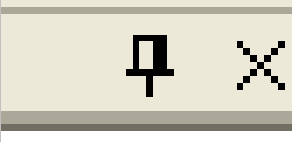
Now we have mastered the basics of moving our forms around and laying them out, let’s see what we can do when that screen is REALLY crowded.
So far, you haven’t asked about that little push-pin icon at the top of our forms next the close-down ‘X’. So far, we’ve left our forms ‘pinned’ in position.
Let’s change that. Choose a push-pin and click it.
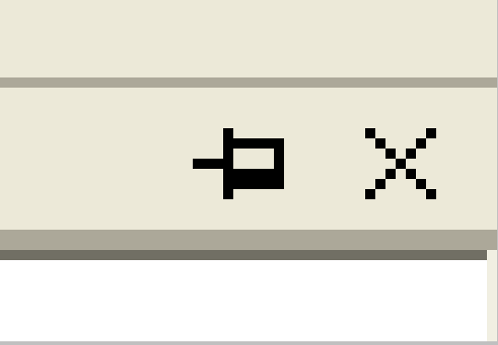 Drunken push-pin
When you click the push-pin, it falls over.
The other event that will occur is that the form will hide itself away. It becomes ‘unpinned’ and appears to slide off the edge of the screen.
The remaining screen re-arranges itself and the space previously taken by the hideaway form is shared out amongst the nearby forms.
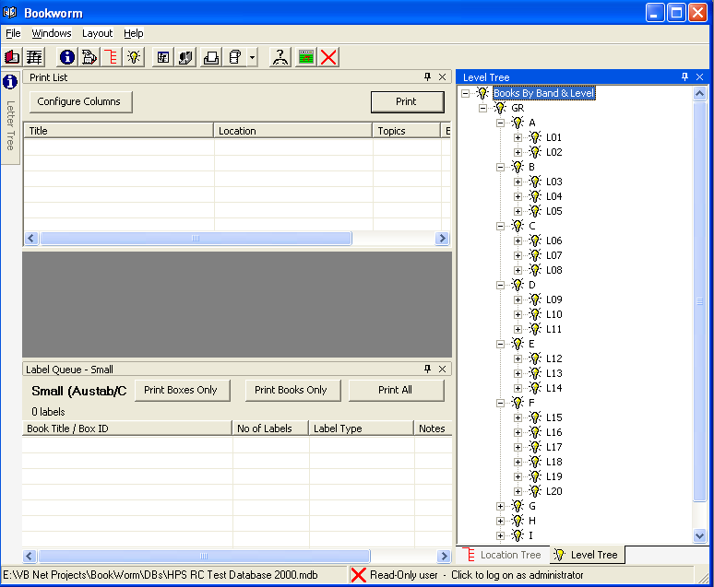 When we have a screen as small as this, we have to use every trick in the book to maximise use of screen real estate. Let’s click the push-pin on the Level Tree.

When we click the push-pin on the Level Tree in the screen above, both the Level Tree AND the Location Tree will slide away. The push-pin applies to the PANE, not to a single window in it. When forms are sharing a pane they are hidden or revealed together.

To retrieve the hidden forms, simply hover your mouse over a tab and the pane will slide out over the top of the other panes. When it slides out, the pane will temporarily hide some of the rest of the screen. Within the slideout pane, the form which had its tab chosen will be on top.
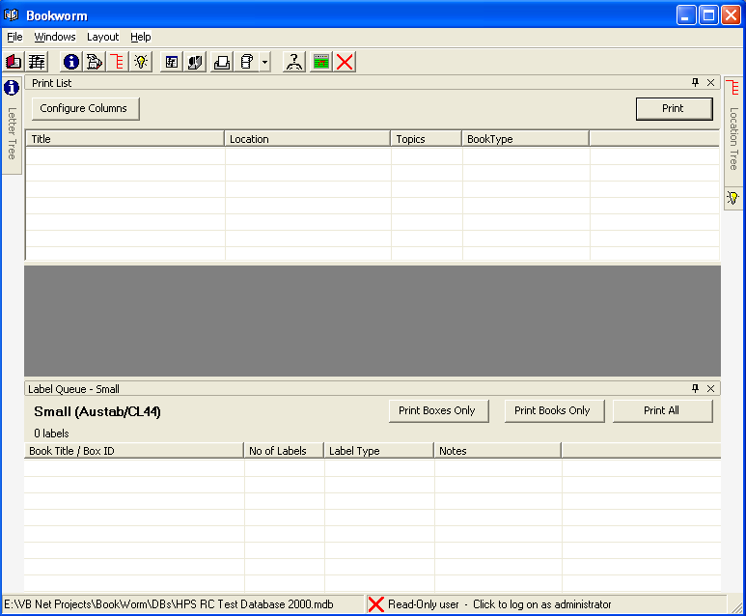 We’ve ‘lost’ the Location Tree AND the Level Tree.
Note the tabs on the right.
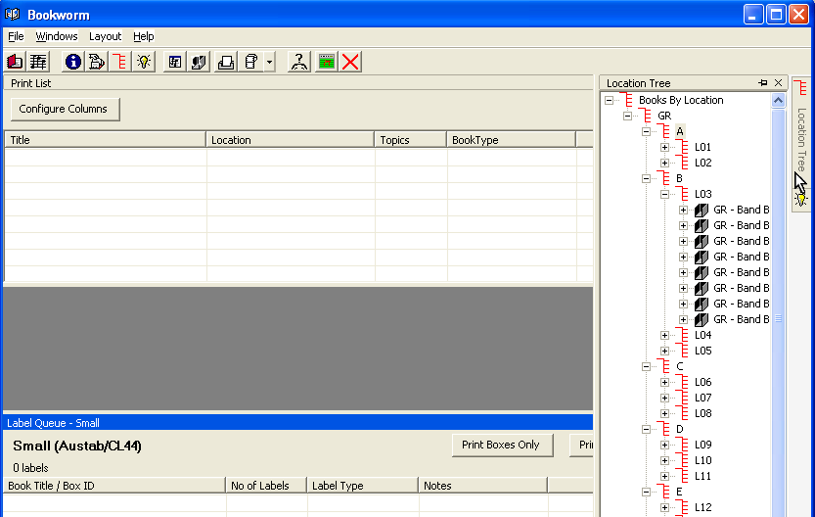
The pane will remain revealed until the mouse is moved off the form. If another form within the slide-out pane is wanted, move the mouse cursor over the tab for the form.
If a form on the slide-away pane is clicked, the pane will remain revealed – but not pinned out – until a form on a different part of the screen is clicked – irrespective of the location of the mouse cursor.
To pin a pane in the ‘out’ position, click on its push-pin while it is slid out.
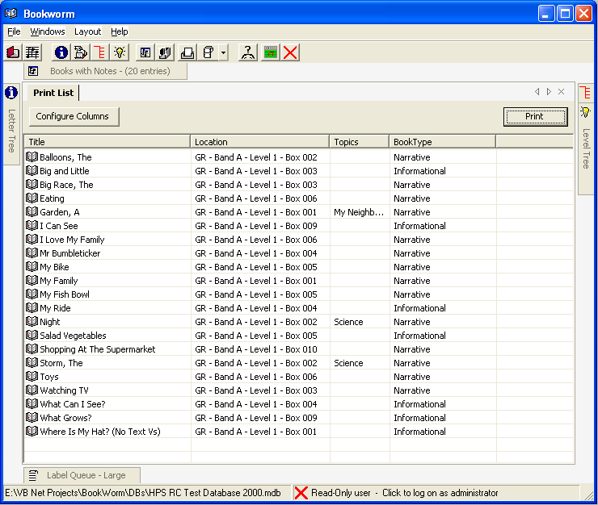 How to squeeze six forms into a tiny space – and still have room to work.

This is what happens when we slid away all the forms in the first diagram in this section.

